200 CV Thought for the Nativity – Christmas II
by Didymus
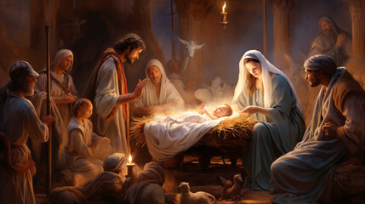
Evensong Readings
Isaiah ch.35
Luke ch.2, vv.41-end

Well, it’s a nice picture of the most wonderful event in our history, and it is well worth repeating. Mary, Joseph and Jesus are there, with the shepherds, and I am sure that the artist has included the innkeeper’s wife and her maid are there, too. He or she has not yielded to the current temptation to put in the Wise Men as well, although I am sure that they are not far off, with their camels stamping and snorting and some servants unloading their gifts.
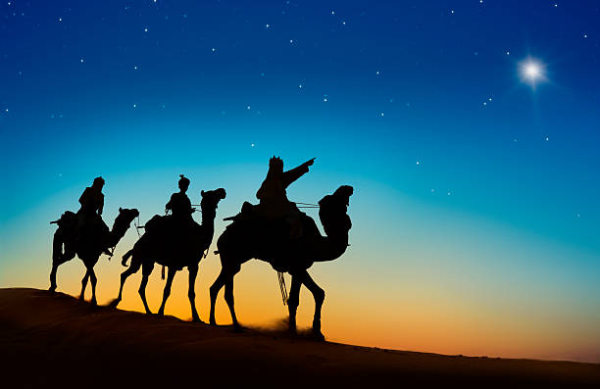
However let me not keep the Wise Men waiting. It is a charming tale which invites scepticism if not plain disbelief. I assume that Mary and Joseph were allowed to stay on in Bethlehem, as a newly born baby would need time before setting out on a long journey. The Wise Men met Jesus, and presented him with his gifts of gold, frankincense and myrrh. Gold for a king, frankincense for deity and myrrh for sadness.
Herod was king of the Jews, and was wary of any move to replace him. He sought out the Wise Men and asked them to tell him where Jesus was. The Wise Men were not so named without reason, and they left by another route. Joseph was warned in a dream that they should escape to Egypt, which they did. I feel that the Wise Men might well have warned Joseph as well. Herod, beside himself with fear and anger, ordered a slaughter of the younger boys around Bethlehem. It was a pointless evil. That year (4BC) Herod was killed
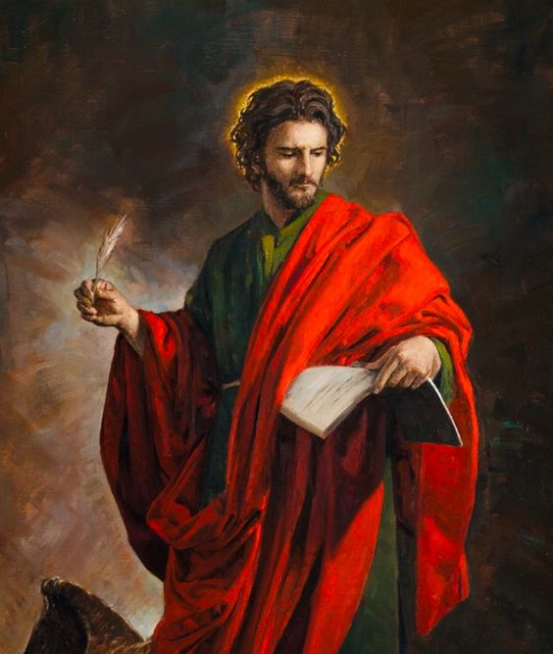
The important celebration at the time of writing (27th) is the memory of the man whose Gospel tells us so much about our Lord Jesus Christ. St.John was the Disciple, Apostle and Evangelist, one of the Boanerges (“The Sons of Thunder”). We cannot be sure who inspired or wrote the Fourth Gospel, a Gospel that is remarkably different, well named the Spiritual Gospel.
There are many Johns in the Bible – “God has been gracious” in Hebrew. Scholastic opinion appears to be unsure as to the identity of the author, especially as the Disciples became the centres of teaching. For example, Matthew had a “school” at Antioch. To me, it feels Johannine, even if the followers of St. John corrected and completed the text. I will return more fully to John in 2024: you have been warned!
I recorded the Midnight Service from Portsmouth Cathedral as we have family connections with that fair (? – Ed) city. It is good to say that the Bishop, Paul Croft, gave a good short sermon. He hit the right note referring to football, for Portsmouth requires two things of a resident – are you in the Navy and do you support Portsmouth football team? (Unlike the last bishop I heard preach, who took more than 20 minutes and I’m sure that he read it twice. Perhaps he wasn’t sure about it, either.)
It was much as Midnight always was with a cast of hundreds, robes, candles of every size everywhere. The congregation were holding candles, and I was surprised that a the H&SE didn’t send the local fire crew to rush in with hoses. Someone has some common sense about fire risk.
I hadn’t been to Holy Communion for ages because, while it is a reaffirmation of our closeness with God, the New Covenant tells us that, if we take Jesus into our lives, he will take us into his. Not just on Sunday. There is to me no reason why a sincere Christian cannot ask God’s Blessing on food, love, or endeavour. It is not a privilege for dog collars only, other than to protect the role of the clergy. I remember Bishop Bill worrying about the morale of the priesthood in the context of allowing communion by extension. It was OK on weekdays with penny numbers in church, but not at weekends.
I do find it theologically nonsensical that we celebrate our Lord’s birth by remembering his death. Yes, he came to remove the curse of mortality for those who believe. I suppose different folk see it in slightly different ways. I remember a friend who dragged a metaphorical van load of guilt with her. Did the prayer of Absolution mean nothing? He came to teach us life and love, to go and preach the Christian Gospel. And he came back, Resurrected, to show us the truth of his promise that “All who believe in me will not die but inherit eternal life”.
The 200th TFTD. Where on earth has four years gone? I remember my anger at the closure of our churches by a supine church and a government of fools led by a brainless womaniser. Faced by an unknown and potentially lethal virus, where do people want and need to go? For those called to preach and teach, their ministries were stopped. So I decided to use the internet, first, hence my use of the phrase “the long arm of boredom”. Later I used appropriate illustrations which seemed helpful, mainly off the internet, but also “borrowed” from newspapers to illustrate the senseless slaughter of Ukraine and Gaza. I used the pseudonym because I am sorry for Thomas. He was asked to believe the incredible, and he simply wanted to be sure. His confession was indeed incredible.
It has been rather liberating to rail against the blindness and stupidity of the church organisation, a largely good and Christian group of chaps, which exists to preserve the status quo. We even have a General Synod to ensure that nothing changes.
It is ironic that the early church fought against heresies such as Arianism and Gnosis, notably Bishop Athanasius, the Bishop of Alexandria. These two heresies proposed that religion and worship had a structure, where the more senior one grew, the more important truths were revealed to them. The result of ridding the church of these and other heresies was the inclusion of the Creeds, Nicene, Apostolic and Athanasian in worship. They are simply statements of doctrine and belief which unify us together.
That is exactly what the church is doing now, with quasi – military structures of assistant curates, curates, priests, rectors, rural deans, archdeacons and a multiplicity of bishops, all with expensive robes of office. They even have titles that say who is more reverend than who. The laity are the NCOs. Small wonder that a survey of clergy admitted that they felt that they had lost confidence in what they were doing.
The service at Portsmouth was warm, and uplifting. It was good to see, even if nothing had changed since my first Midnight in 1955, nearly 70 years ago.
PRAYERS
In our prayers, in giving thanks for all that we have been given in life and love, we must think of those without. Let’s remember those who have just lost a loved one at a bad time, or suffered a tragedy, or are in treatment for a serious illness. Let us also remember those who live alone, the elderly and those without transport to travel to friends. We pray for those who are without a home, a place to call their own, people who cannot find work and pay, and those who cannot work for one reason or another.
We pray for those in danger in Ukraine, Gaza, Yemen, with danger around every corner from people who know no God, no Jesus, with a sullen implacable hatred.
Please pray for those far less fortunate than we.
AMEN
Illustrations: The Nativity, the Wise Men, and Saint John.
FINALLY, I WISH YOU A HAPPY NEW YEAR.
ON A LIGHTER NOTE, A CARTOON BY PETER BROOKES OF THE TIMES.

